

PICA Photo Gallery
Version 1.0
Pica Photo Gallery User Guide

Index

1. Description of the Extension 1
2. Key Features 1
3. How to Install? 1
4. Back end 5
5. Front end ........................................................................................................................................................12
5. Step by Step configuration 17
5.1 Requirements 16
5.2 Facebook App ID 16

Description of the Extension

PICA is a photo gallery extension which shows up your photos in an impressive and memorable way.
The gallery extension easily organizes your large set of digital photos, edit images and create multiple
albums. You can view the images in a full screen slide show view, giving the user a better website
experience. The gallery extension facilitates to download the full-resolution pictures, Facebook share
and Zoom in/out for each photo. The PICA Photo gallery provides seamless transition between
images catering proper attention to the website.

Key Features

- Manage the stack of photos in categories as featured photos as seen in Picasa Gallery.
- Facility to manage list of album under featured photos.
- Facility to Resize Featured photos, Album photos, Photo thumbnails and Large Photos with respect to given width and height.
- Facility to manage Albums as widget.
- Organize any number of photos in categories for easy navigation
- Photo view with Facebook share/download/zoom in/zoom out
- Full Screen Show for each image
- Whole Design replicates Picasa design
- Short code provided for displaying albums only [picagallery]

How to Install?

- Log on to your Wordpress admin.

Go to Admin Menu →Plugins → Add New→ Uploads→Choose File→select PICA Photo Gallery Zip file from your local system → Install Now

[Refer the below screenshot]

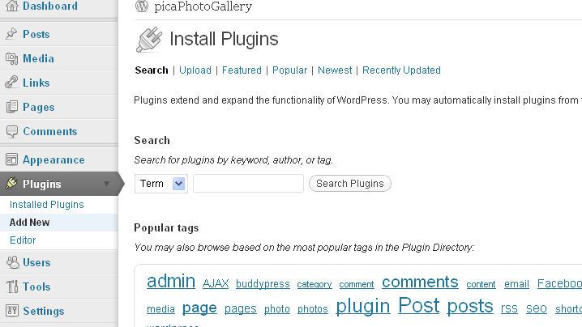

Click on upload link and select picaphotogallery.zip file as shown bellow.

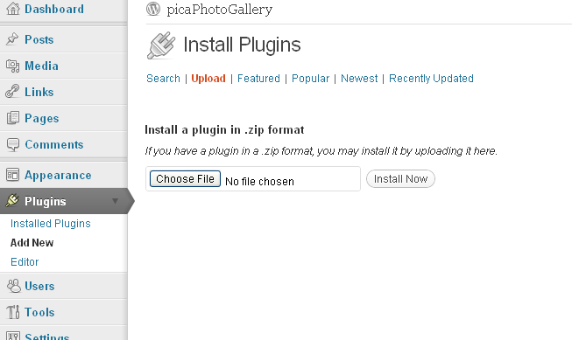

You will see the installed PICA Photo Gallery Plugin placed in the Active Plugin list with message “Plugin Activated”. The PICA Photo Gallery sub menu is now seen in the Administration Menu.
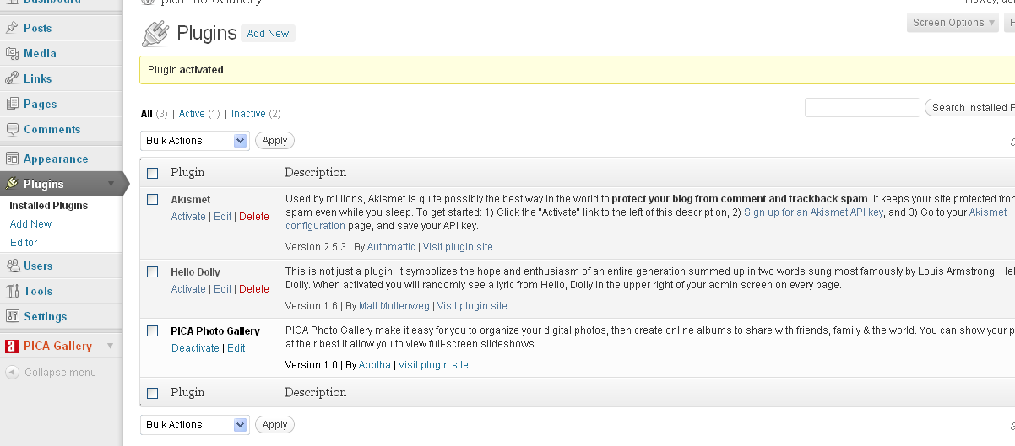

Back end

1. PICA Gallery menu creates 3 submenu listed as below

  - Albums :
  - Upload Photos
  - Settings

Here you can create any number of albums, edit/upload photos in albums, delete photos from albums, change status and delete albums.

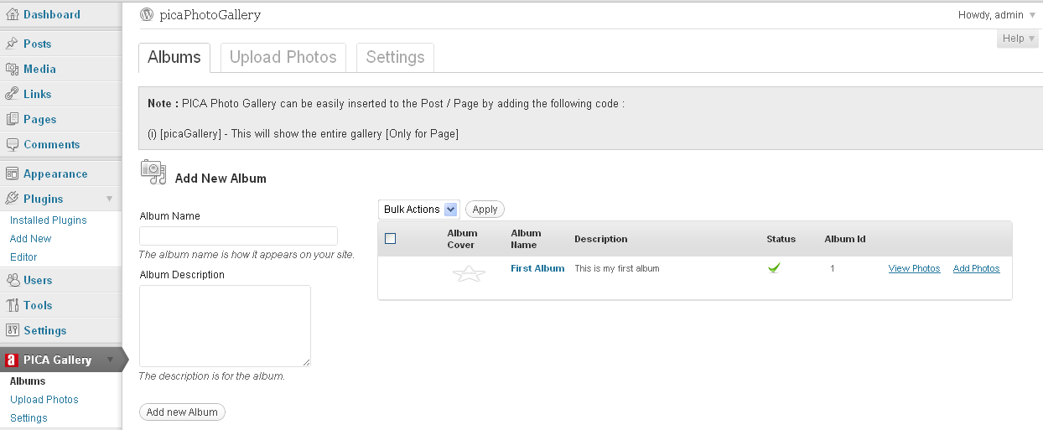

To create new album, enter album name, album description, add photos and click on Add New Album tab.

Refer Screenshot

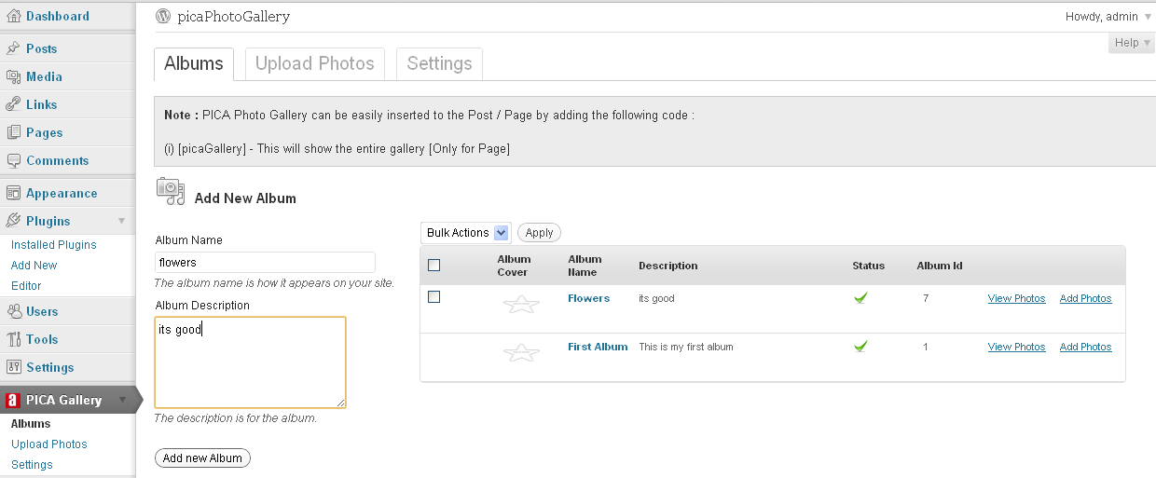

How to Edit Album name and Description?

Click on Quick Edit that display the two text boxes to edit name and description of Album. Edit text on textbox then click on Update button.

How to View Photos in Album?

Click on View Photos, it redirects to another page which shows all photos in Album. You can edit or add photos in albums, Click on Update button to save all changes.

How to Add Photos in Album?

Click on Add photos, new page opens where you can chose the album to add photos. Click on Select file, upload photos from your pc, add description, title and tag and Click on Update button.
The Albums list is stored in pica_albums table.

1.2 Upload Photos:

It allows the users to upload multiple photos or single photo into a specific gallery. Before uploading any photos, you must create minimum of one album to upload photos
Click on Upload photos tab, Select one album from drop down list, Click on Select Files, Select one or multiple photos from your local system, Click on Open, upload all photos, enter title and description and Click on Upload.

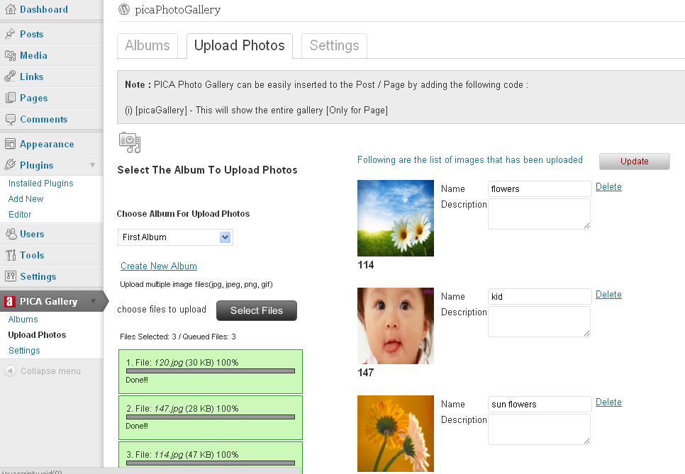

You will now get to see the list of photos in selected album as shown below.
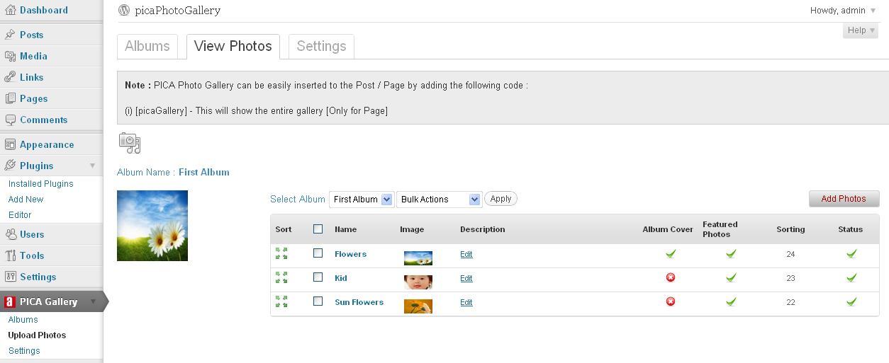

The Featured Photos column display the Photo in Featured photos list in front page.
Sorting column enables to sort the photos as per your wish. This allows you to change the display order of photos.
Status column is used to set/hide the photo display on front end.

The Photo are stored in pica_albums table .
1.3 Settings:

The settings menu lets you to control the front end options.
This submenu has 4 Meta boxes as listed below.

1.3.1) Featured Settings
1.3.2) Album Settings
1.3.3) General Settings
    - Photo Settings

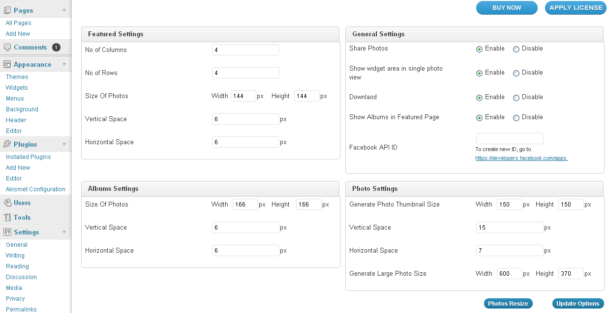

Featured Settings:

This settings are use to control the front view of the Featured Photos. It contains the number of setting options which enables to change the Featured photos view.
The List of settings are:

No of columns: Used to provide the number of columns that should appear in the front end. It should be a numeric value.
No of Rows: Used to provide the number of rows that should appear in the front end. It should be a numeric value.
Photo Size: Set the height and width of the image. (in Px)
Vertical and Horizontal space: Used to set the vertical and horizontal spacing between the images. (Px)
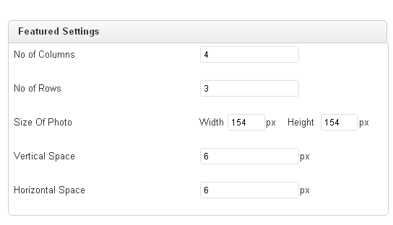

Album Settings:

The settings are use to control the front view of the Album in Featured page. It contain the number of setting options which enables to change the Album view.

The List of settings are:
Photo Size: Set the height and width of the image. (in Px)
Vertical and Horizontal space: Used to set the vertical and horizontal spacing between the images. (Px)

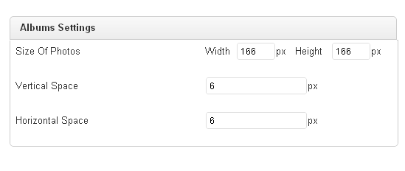

General Settings:

The general settings enable to control the front view. Here, you can allow the users to share your photos or download or take print and so on. It contain the number of setting options to change the front view .

The List of settings are:
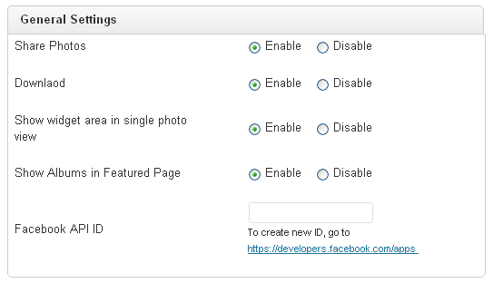

Download: Allows the users to download your photo.

Share Photos: Allows the users to Share your photos in social websites like face book .
Download : It allows the users to download the photo
Show widget area in single page : It hide the widgets in single photo view .
Show Albums in Featured page: Allows the users to show your Albums list in Featured page.
Face Book API ID: This option is discuss in 7.2 session.

Photo Settings:

The settings enable to resize the upload photos in different sizes like 144px, X144px. You can create the thumbnail size of photo of any desired width and height, or set to normal size photos. The Featured photos or albums images should display as thumbnail size so as to create the species size of photos.

Refer screen shot.
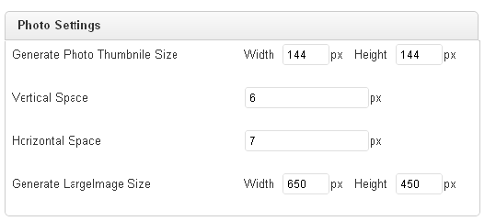

Vertical Space: It set the top, bottom margin between photos showing in album
Horizontal Space: It set the left, right margin between photos showing in album

BUTTONS:

Photos Resize:

Registers a new image size. This creates a copy of the thumbnail with the specified dimensions when you upload a new thumbnail. You can also change the photo dimensions of specific photos like featured photos, album photos and large Photo sizes by editing the text boxes like width, height values.

Update Options: Stores the settings menu values in pica_settings_menu table.

PAGE
After installing the plugin in pages PICA Photos page will be created in content with short code like [picaGallery].

Note: if you remove this short code, the photos will not be displayed in the front end.

USE OF SHORT CODE: You can add short code of PICA Photo Gallery [picaGallery] in any page or post as you wish. An example of adding shot code in sample page is shown below.
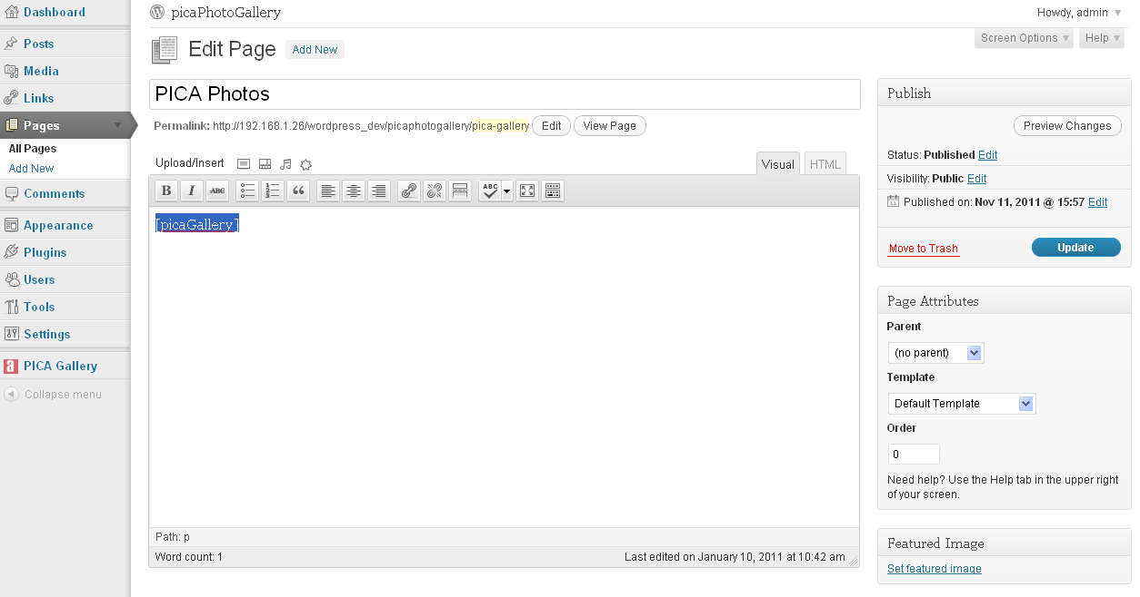
USE OF SHORT CODE: You can add short code of PICA Photo Gallery [picaGallery] in any page or post as you wish. An example of adding shot code in sample page is shown below.

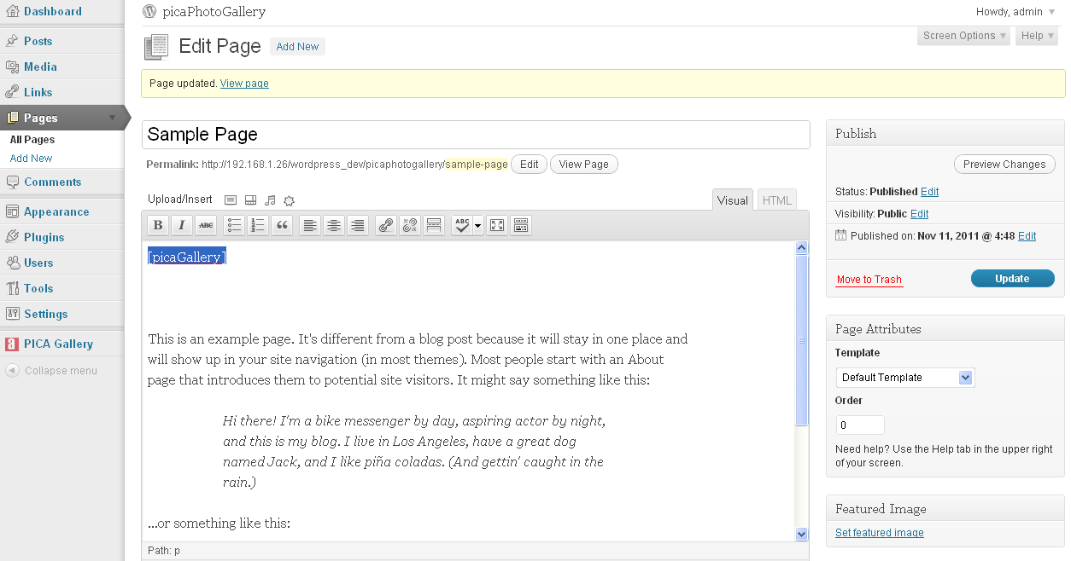

5 Front end
Click on PICA Photos page in menu, you will get Featured photos and slideshow below the Featured photos .
Featured Photos

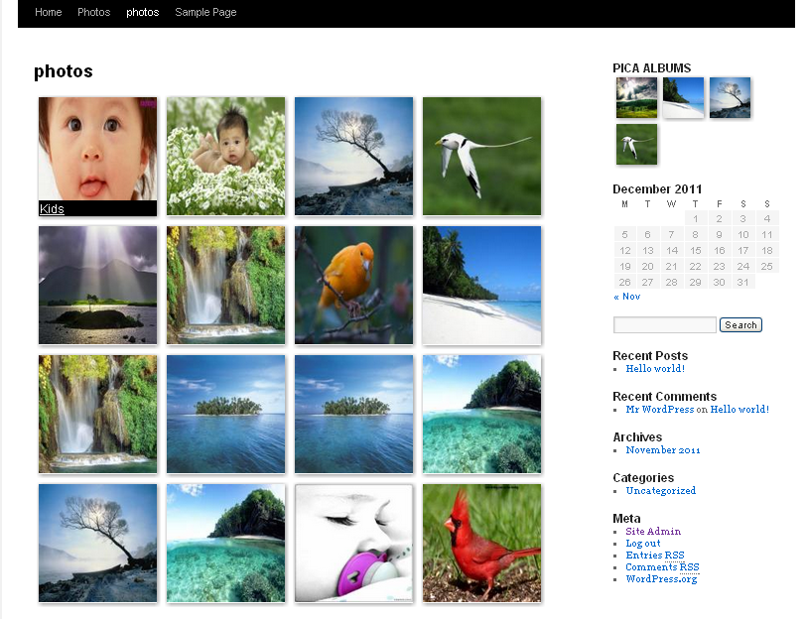

Album slideshow

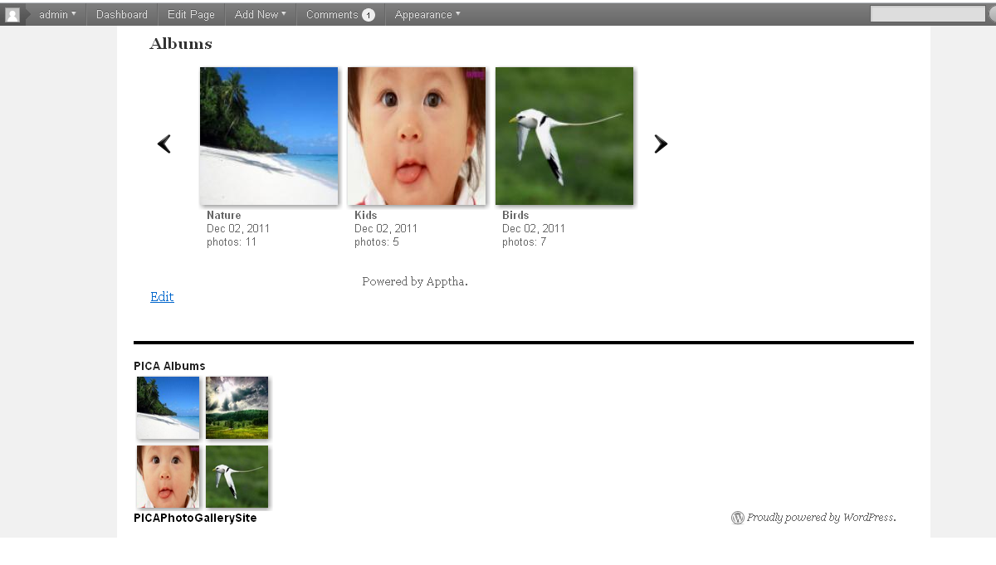

In Featured photos we have two options to show photos
- Show Photos in Album
- Show single photo as big image

- Show Photos in Album

When the mouse is rolled over on a photo, it displays the Album name and by clicking the album name all photos under the chosen album are displayed.

Refer screenshot

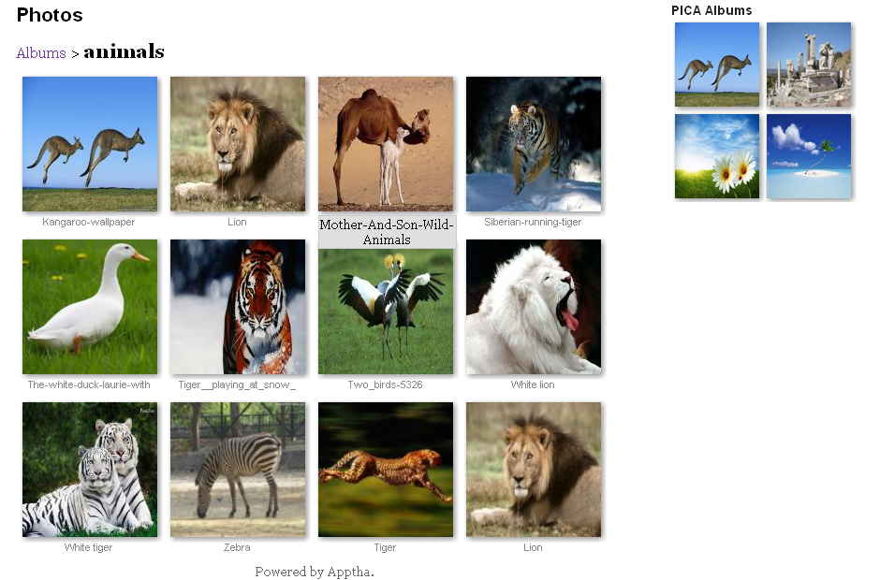
  - Show single photo as big image

By clicking a photo in Featured photos or album photos, the big image of the chosen photo is displayed with options like zoom in, zoom out, download, facebook share and pagination option. Refer Screenshot.

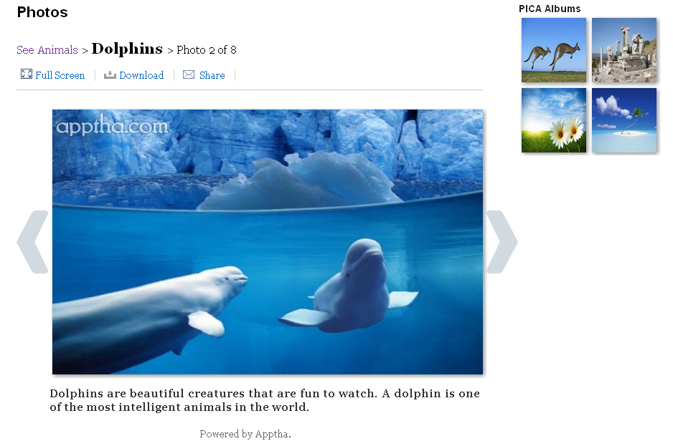

Click on Full Screen button it display the photo
hear into symbol for close the window
plus symbol for zoom out
minus symbol for zoom in

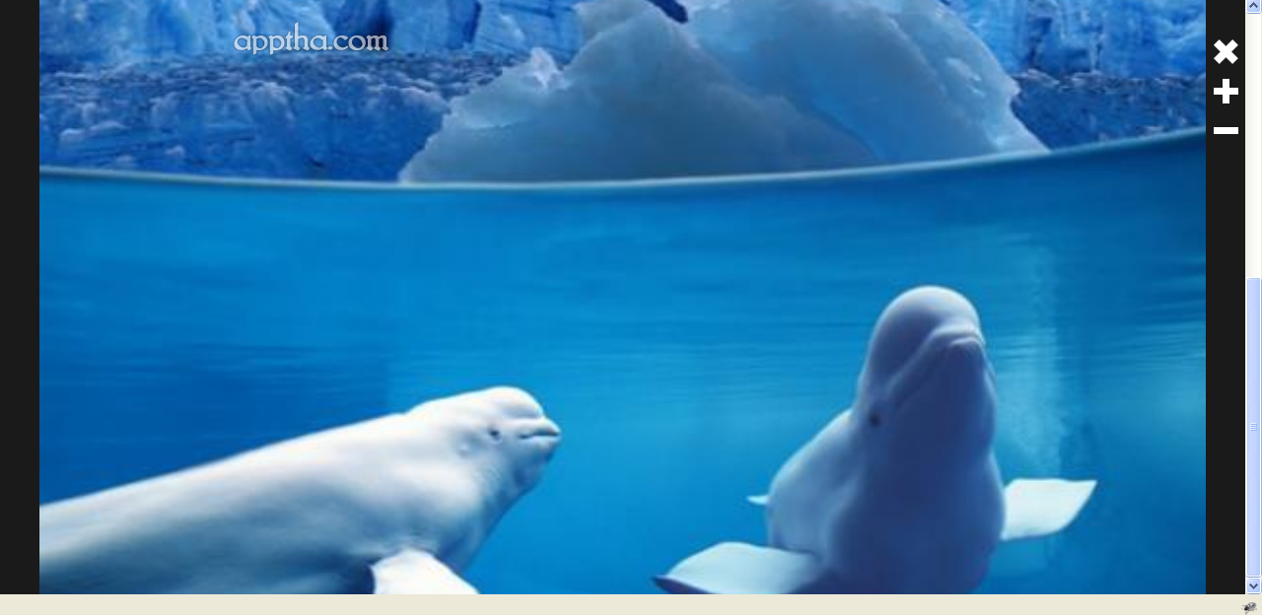

Step by Step configuration

Requirements
For detailed system requirements, follow wordpress system requirement link given below
http://wordpress.org/about/requirements/

Facebook App ID

Facebook App Id:
You can get the facebook app id through your facebook application. Kindly go through the below steps to create app in facebook

Facebook App Secret Key:

You can get the facebook app secret key through your facebook application. Kindly go through the below steps to create app in facebook.

Following instruction will guide you to create an app in facebook:

- If you are using facebook.com for the first time, then register with facebook.com. Note: (For first time only) if you have not verified your account, verify your account using mobile phone or credit card.
- Open the page https://developers.facebook.com/apps after you have logged in.
- You will see the button “+Create New App” on top of the page. Click on it.
- After setting up App Display Name: & App Namespace:, you will be redirected to the Facebook app basic page.
- See the tab “Select how your app integrates with Facebook” on bottom and click on the tab “Website”, there you need to enter your wordpress site. For example “http://domain.com/”
- Now you have successfully created an app.
- Go to app home page and get the following details
a) Facebook App ID,
b) Facebook App Secret,
